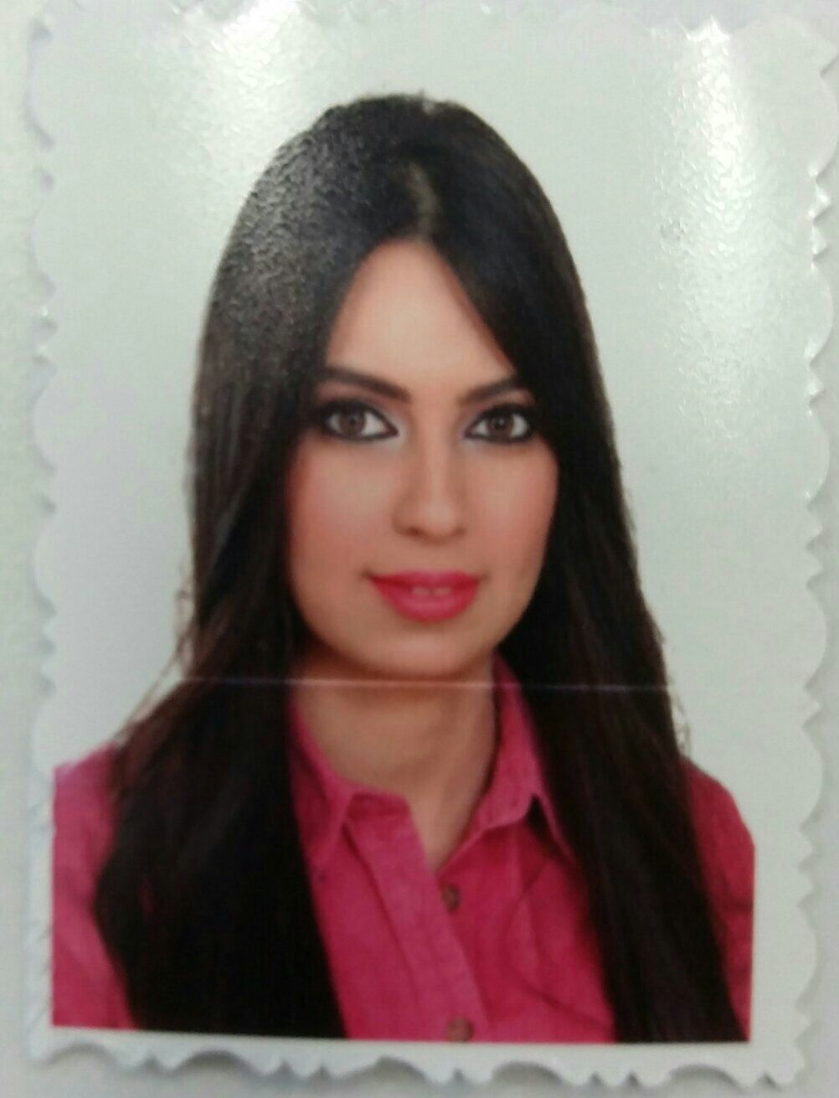

# Oula Hadi Hussien

## Education

## Bachelor's degree in software engineering

At Almansour University College  
**Location:** Baghdad, Iraq   
**Completion Date:** September 2014

## Personal Information

**Birth Date:** 12 june1992 (Age: 26)

**Gender: Fe**male

**Nationality:** Iraq

**Address:** Baghdad\alshaab

## Contact Information

**Email Address:** *aula.92june@yahoo.com*

**Mobile Phone:** +964.7717397319

## Skills

### Programming languages: C++, Java

### Experience in Microsoft Office Excel &word & Photoshop

### Im work well on MS.Outlook & QuickBooks system on line , Main Frame System of TNT Express

### Accountant & data entry ( Experience two year in khz company (Huawei agent in Iraq))

### Administrative in BCI Samsunge

### Customer Service in FedEx Express

### Administrative in Taqadum Al-Iraq agent of ( FedEx & TNT ) Express .

## Languages

### English ( on average ).

**certificate from Al_Ebdaaa Center (Administrative qualification).**

